**KALLAM HARANADHAREDDY INSTITUTE OF TECHNOLOGY**

**PROJECT TITLE**

**A CRM APPLICATION ON E-COMMERCE ACTIVITIES**

Team Members

Vanukuri Likhita

[218x1a42c6@khitguntur.ac.in](mailto:218x1a42c6@khitguntur.ac.in)

Pattan Jani Basha Khan

[218x1a42co@khitguntur.ac.in](mailto:218x1a42co@khitguntur.ac.in)

Shaik Ayub

[218x1a4285@khitguntur.ac.in](mailto:218x1a4285@khitguntur.ac.in)

Pulagam Ananth

[218x1a4276@khitguntur.ac.in](mailto:218x1a4276@khitguntur.ac.in)

**Project Abstract**

The "**A CRM APPLICATION ON E-COMMERCE ACTIVITIES**" project aims to develop a Customer Relationship Management (CRM) system within Salesforce to manage e-commerce transactions effectively. This project focuses on creating a seamless customer experience, enhancing sales operations, and improving business insights through reports and dashboards. The implementation includes creating custom objects, fields, tabs, and automation features such as Apex and Apex Schedulers. This documentation details the objectives, methodology, implementation, outcomes, and future recommendations of the project.

**INDEX**

1. Introduction
2. Objective
3. Implementation

* 3.1 Salesforce
  + Creating Developer Account
  + Account Activation
* 3.2 Object Creation
* Create Translists Object
* Create Details of customer Object
* Create Item Object
* 3.3 Tabs
* Creating A Custom Tab For Translists
* 3.4 Fields
* Creating Fields For Translists Object
* Creating Fields For Detailsofcustomer Object
* Creating Fields For Items Object
* 3.5 The Lightning App
* Creating An App (E-COMMERCE)
* 3.6 User Adaptation
* Create A Record For Items Object
* Create A Record For Translists Object
* 3.7 APEX
* Identifying Potential Customers
* 3.8 Apex Schedulers
* Schedule The Class
* 3.9 Reports
* Create Report For Translists
* Create Report For Items
* 3.10 Dashboards
* Create A Dashboard On Translists Report
* Create A Dashboard On Items Report

4. Outcomes

5. Challenges & Solutions

6. Key Scenarios Addressed For Salesforce on Implementation of Project

7. Conclusion

**INTRODUCTION**

In today’s digital era, businesses in the e-commerce sector require robust Customer Relationship Management (CRM) solutions to manage customer interactions effectively. CRM plays a crucial role in maintaining customer relationships, improving sales processes, and optimizing business operations. A well-implemented CRM system can automate customer tracking, streamline communication, and provide valuable insights through analytics.

The "A CRM APPLICATION ON E-COMMERCE ACTIVITIES" project aims to leverage Salesforce to develop an advanced CRM application that enables businesses to manage transactions, customer details, and product listings efficiently. The CRM solution will include custom objects, field creation, tab customization, automation using Apex, and dashboards to visualize business performance. By utilizing Salesforce’s robust platform, this project will ensure improved data management, better customer engagement, and enhanced operational efficiency for e-commerce businesses.

One of the primary challenges for e-commerce businesses is handling large volumes of transactions and customer data. With an increasing number of online shoppers, businesses require a centralized system to store and analyze customer information. Additionally, tracking sales performance and identifying potential customers play a critical role in revenue growth. This project will address these challenges by implementing a structured CRM system that supports automated scheduling, transaction management, and reporting functionalities.

By integrating key features such as custom objects, fields, reports, dashboards, and automation tools, this CRM application will offer a seamless experience for businesses to manage their operations effectively. The implementation of Apex and Apex Schedulers will further automate routine tasks, reducing manual efforts and improving overall productivity. Furthermore, the CRM system will allow businesses to generate insightful reports, helping decision-makers optimize sales strategies and enhance customer engagement.

**OBJECTIVES**

* **Enhance Customer Management**: Develop an efficient system to manage customer details, purchase history, and interactions. The CRM will help businesses store customer data securely and retrieve it when required, ensuring better service and personalized engagement.
* **Streamline E-Commerce Operations**: Automate and optimize sales processes, order tracking, and delivery management. The CRM will provide a structured way to handle online transactions, ensuring accurate tracking of each order from initiation to completion.
* **Automate Key Processes**: Implement automation through Apex and Apex Schedulers to handle repetitive tasks such as sending order confirmations, follow-ups, and reminders. Automation will reduce manual effort and improve efficiency.
* **Generate Business Insights**: Provide detailed analytics and reporting features to help businesses analyze sales trends, customer behavior, and revenue growth. Reports and dashboards will facilitate informed decision-making.
* **Improve Customer Retention**: Enable businesses to track customer interactions and offer personalized services, such as targeted promotions and loyalty programs, to improve customer satisfaction and retention rates.
* **Enhance Data Security**: Implement security measures within Salesforce to ensure customer and transaction data is protected from unauthorized access, meeting compliance standards and industry best practices.
* **Seamless Integration with E-Commerce Platforms**: Allow integration with popular e-commerce platforms such as Shopify, WooCommerce, and Magento to synchronize data and improve operational efficiency.
* **Enable Mobile Accessibility**: Develop a mobile-friendly CRM interface to allow sales teams and business owners to access important data and reports on the go.
* **Optimize Lead Management**: Identify and categorize potential customers, track their interactions, and automate lead nurturing processes to improve conversion rate.

**IMPLEMENTATION**

**3.1 SALESFORCE**

Salesforce is a cloud-based Customer Relationship Management (CRM) platform designed to help businesses manage their customer data, sales, marketing, and service operations efficiently. It provides tools for automating processes, generating insightful reports, and enhancing customer interactions. The platform supports various industries, including e-commerce, by offering solutions for tracking transactions, managing customer interactions, and optimizing marketing strategies. Salesforce is highly customizable, allowing businesses to tailor the platform according to their specific needs.

For e-commerce activities, Salesforce CRM plays a crucial role in tracking customer purchases, managing sales pipelines, and analyzing buying behavior. With its powerful features such as workflow automation, reports, dashboards, and AI-driven insights, businesses can improve customer satisfaction, enhance operational efficiency, and boost sales. This project utilizes Salesforce to create a CRM solution specifically designed to streamline e-commerce transactions and optimize business decision-making.

**3.1.1 Creating a Developer Account**

1.Visit the **Salesforce Developer** website <https://developer.salesforce.com/signup>

2.Fill in the registration form with details such as name, email, company, country, and username (which must be unique and in email format).

3.Accept the **Salesforce Terms of Service** and click **Sign Up**.

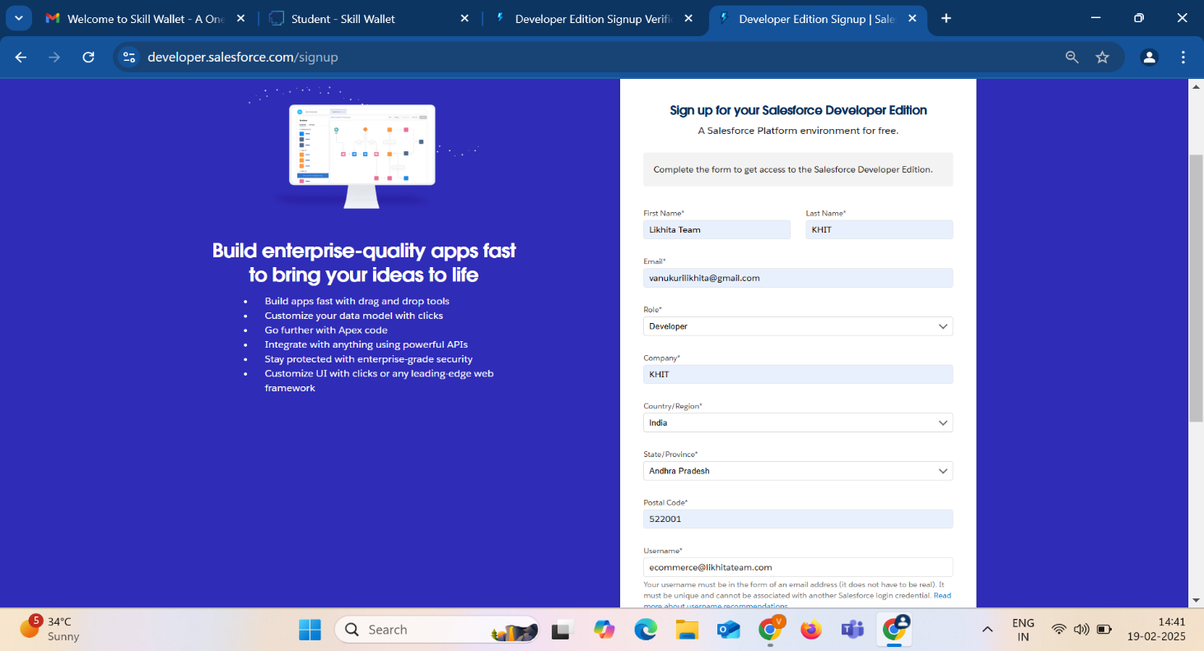

4.A confirmation email will be sent to the registered email ID.

5.Open the email and click on the verification link to activate the developer account.

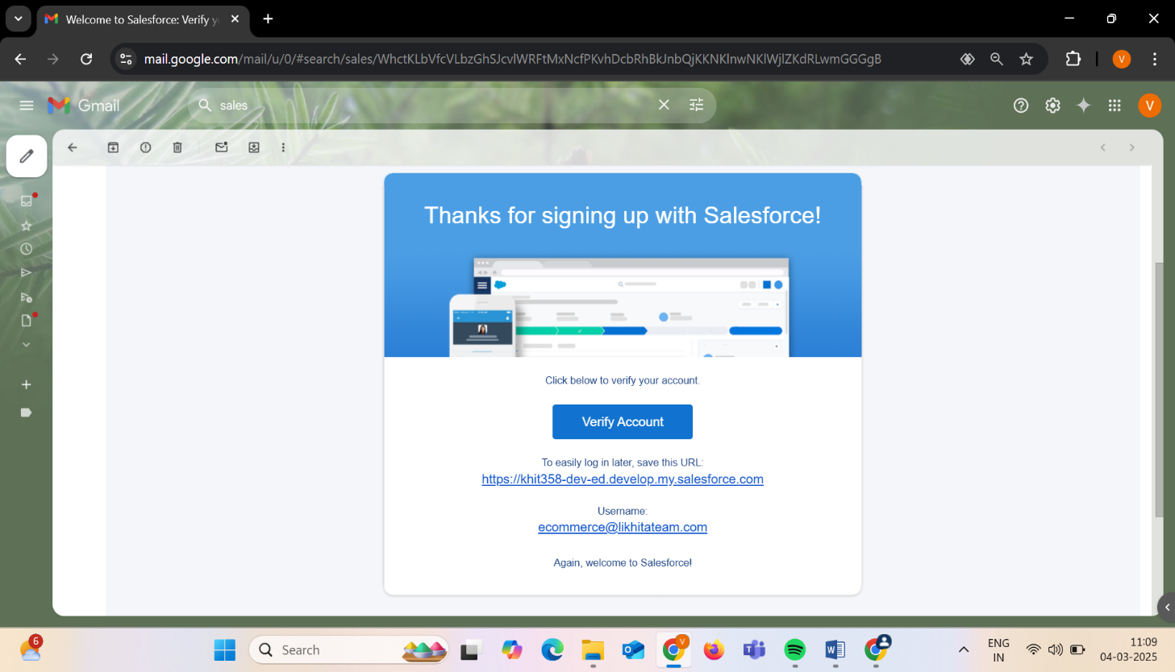

**3.1.2 Account Activation**

1. After verification, log in to **Salesforce Developer Edition** using the provided credentials.
2. Set up a **new password** and security question for future access.

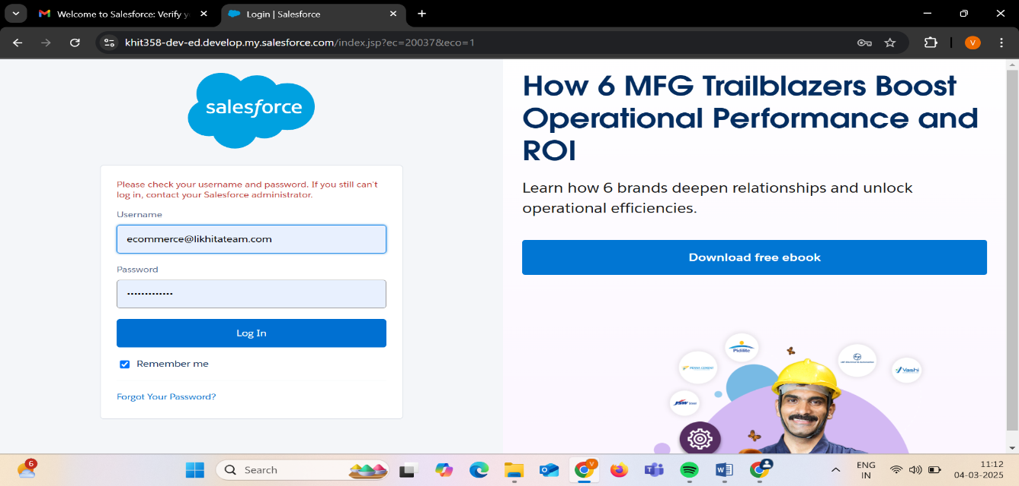

1. Once logged in, navigate to the **Salesforce Setup** page to begin configuring the environment.
2. Configure the **organization settings**, such as company information, currency, time zone, and language.
3. Start exploring the **Salesforce platform**, including Lightning Experience, Object Manager, and App Builder.

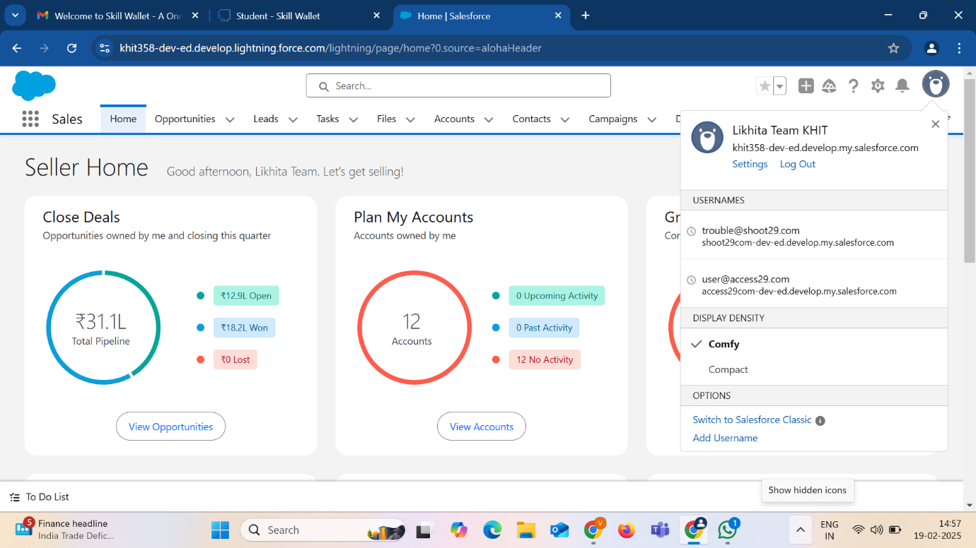

**3.2 Object Creation**

In Salesforce, objects are essential components that store and organize data. They act as database tables where different records are maintained. Objects can be **Standard Objects** (predefined by Salesforce) or **Custom Objects** (created based on business needs). For e-commerce applications, creating relevant custom objects is critical to managing transactions, customer information, and product details efficiently. By structuring data appropriately.

Custom objects in this project will be designed to store key e-commerce data such as transaction details, customer profiles, and item listings. These objects will be linked together through relationships, ensuring seamless data flow between different components of the CRM system. Below is a step-by-step guide for creating custom objects in Salesforce.

**Step-by-Step Process to Create Objects:**

1. To Navigate to **Setup page**
2. Click on gear icon **click setup.**
3. Click on **Object Manager**
4. Click on **Create**
5. Click on **Custom Object**.
6. On Custom object defining page:
7. Enter the **label name**, plural label name, click **on Allow reports**, Allow search.

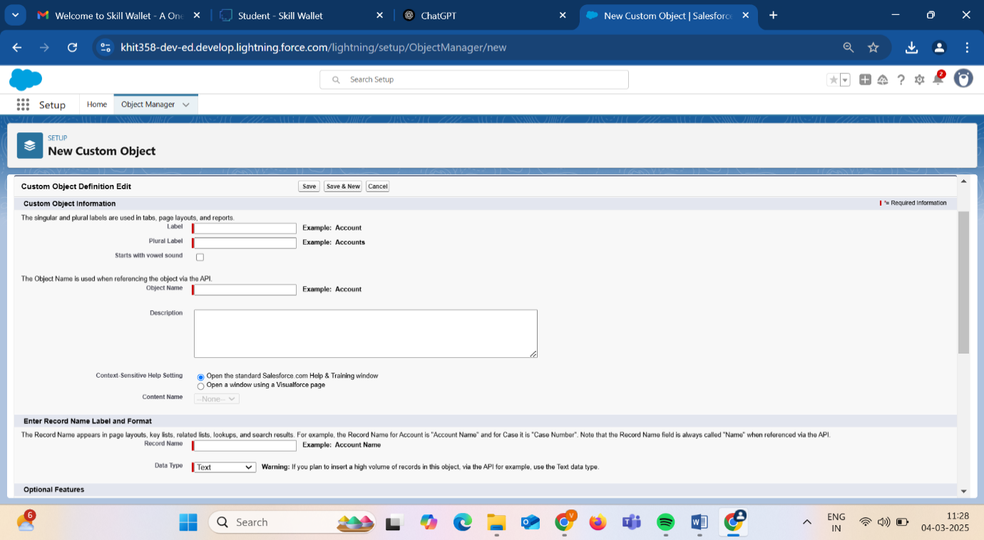

* + 1. **Create Translists Object**

This object is responsible for storing transaction details, including order IDs, customer purchases, payment methods, and timestamps. It helps track sales performance and order histories efficiently.

1. From the **setup page** -> Click on **Object Manager** -> Click on **Create** -> Click on **Custom Object**.

1) Enter the **label name**-> **Translist**

2) Plural **label name**->**Translists**

3) Enter Record Name Label and Format

**Record Name** ->**Translists Name**

**Data Type** -> **Name**

1. Click on **Allow reports** and **Track Field History**
2. Allow search ->**Save.**

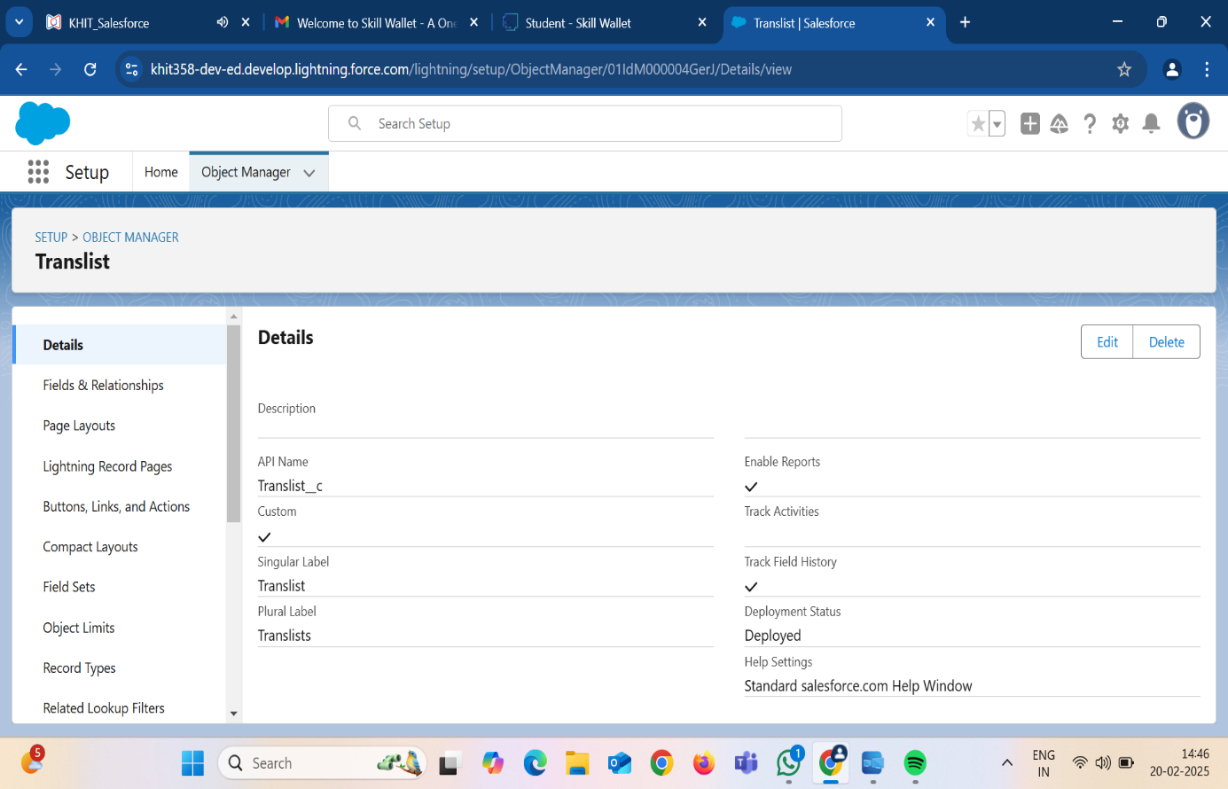

Here we created **translists** object to store all the transaction data that is done in a particular commerce site. And this data, that is acquired is useful to identify the potential customers.

**3.2.2 Create Detailsofcustomer Object**

This object stores customer-related information such as name, contact details, purchase history, and preferences. It helps in personalizing customer interactions and improving engagement.

1. From the **setup page** ->Click on **Object Manager** -> Click on **Create** -> Click on **Custom    Object.**

1) Enter the **label name**-> **Detailsofcustomer**

2) Plural label name-> **Detailsofcustomers**

3) Enter Record Name Label and Format

      Record Name ->**Detailsofcustomer Name**

      Data Type -> **Name**

1. Click on Allow **reports** and **Track Field History**,
2. Allow search -> **Save**.

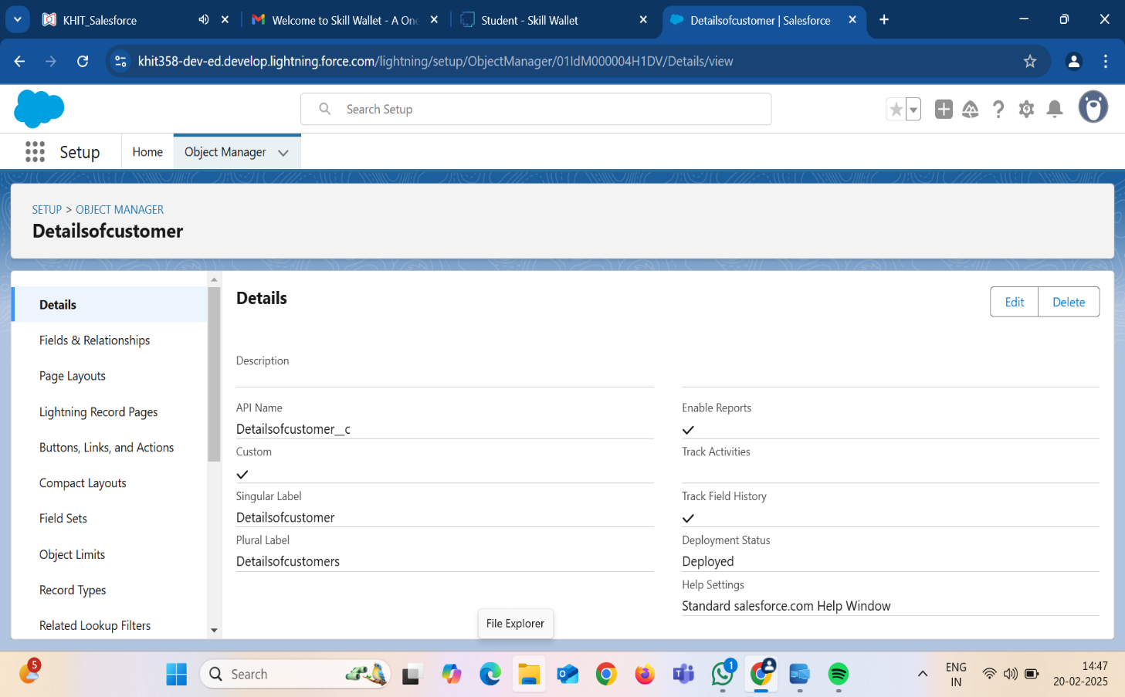

Here we created **detailsofcustomer** object to store all the customer data that is done in a particular commerce site. And this data, that is acquired is useful to identify the potential customers.

**3.2.3 Create Item Object**

This object maintains the inventory of items available for sale, including product descriptions, prices, stock levels, and supplier details. It ensures that products are managed efficiently within the CRM system.

1. From the **setup page** -> Click on **Object Manager** ->Click on **Create** ->Click on **Custom Object.**

1) Enter the label name-> **Item**

2) Plural label name-> **Items**

3) Enter Record Name Label and Format

     Record Name -> **Item Name**

      Data Type -> **Name**

1. Click on Allow **reports** and **Track Field History**,
2. Allow search -> **Save**.

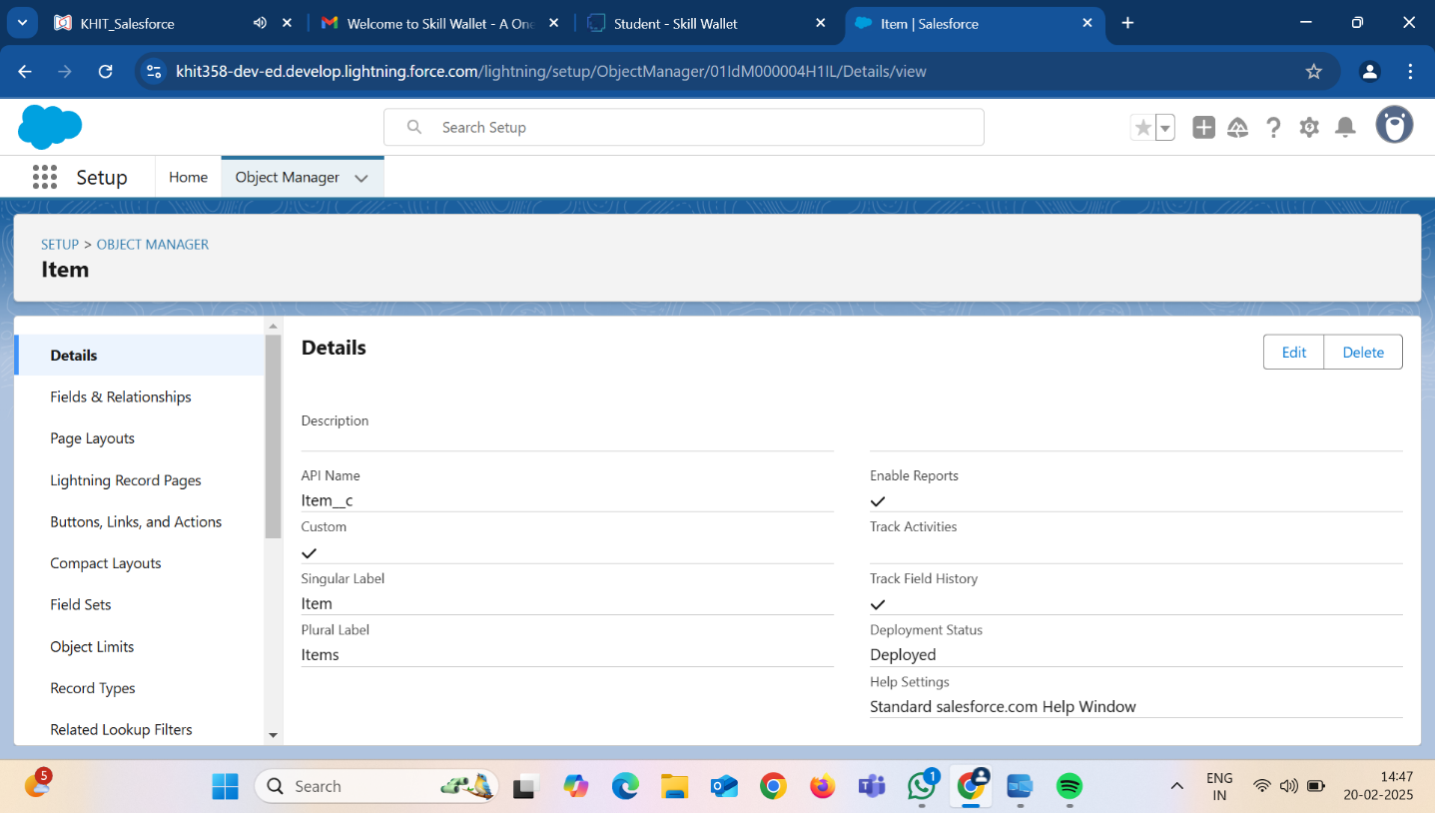

Here we created **item object** to store all the items data that is done in a particular commerce site. And this data, that is acquired is useful to identify the potential customers.

**3.3 Tabs**

Tabs in Salesforce serve as navigation points that allow users to access specific objects, records, and applications efficiently. Custom tabs are particularly useful in providing easy access to custom objects, ensuring that users can quickly enter, retrieve, and manage relevant data.

A tab is like a user interface that is used to build records for objects and to view the records in the objects.

Types of Tabs:

1. Custom Tabs

Custom object tabs are the user interface for custom applications that you build in salesforce.com.

1. Web Tabs

Web tabs make it easier for your users to quickly access content and applications they frequently use without leaving the salesforce.com application.

1. Visualforce Tabs

Visualforce Tabs are custom tabs that display a Visualforce page. Visualforce tabs look and behave like standard salesforce.com tabs such as accounts, contacts, and opportunities.

1. Lightning Component Tabs

Lightning Component tabs allow you to add Lightning components to the navigation menu in Lightning Experience and the mobile app.

1. Lightning Page Tabs

Lightning Page Tabs let you add Lightning Pages to the mobile app navigation menu.

**3.3.1 Creating a Custom Tab for Translists**

1. Go to setup page then type Tabs in Quick Find bar now click on tabs and New
2. Select Object (Translists) -> Select the tab style -> Next (Add to profiles page) keep it as default -> Next (Add to Custom App)  uncheck the include tab ->Save.
3. Make sure that append tab to users' existing personal customizations is checked.

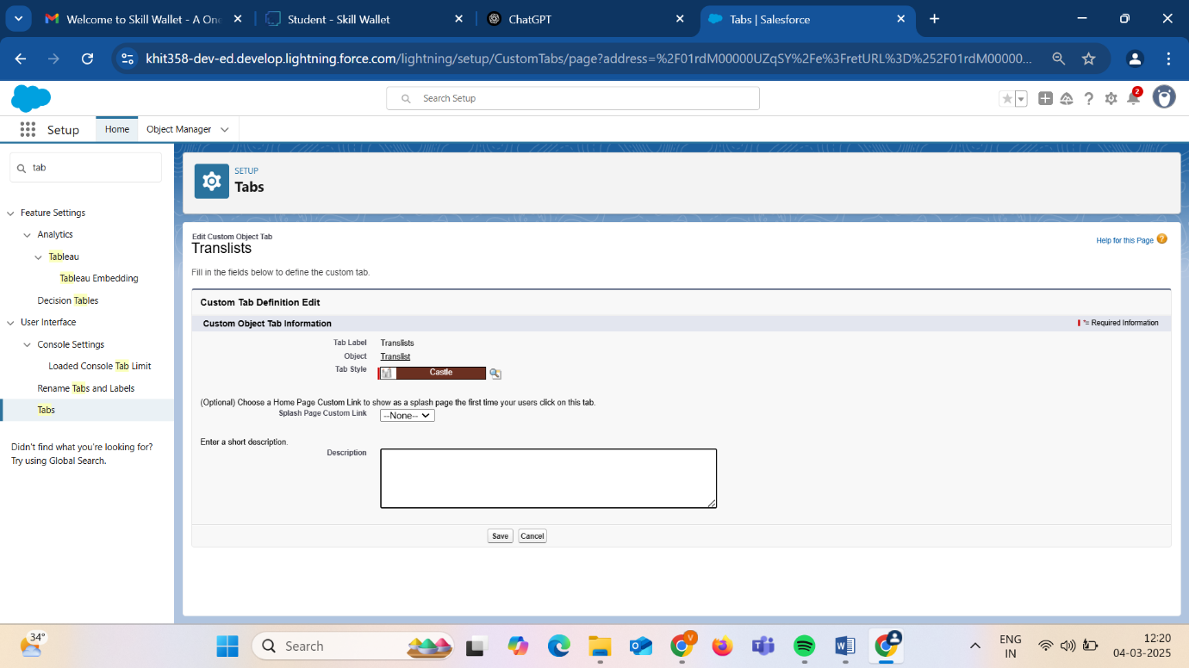

## Similarly, create tabs for **Items** and **Detailsofcustomer.**

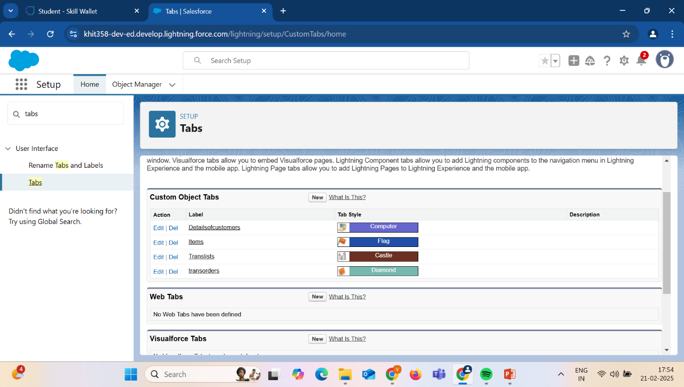

**3.4 Fields**

Fields in Salesforce define the type of data that can be stored within an object. They help organize and structure information, ensuring that the correct data is captured for each record. Salesforce provides **Standard Fields** (predefined fields such as Name, Created Date, and Owner) and **Custom Fields** (user-defined fields tailored to specific business needs). Custom fields allow businesses to store relevant information that enhances their CRM’s functionality.

For an e-commerce CRM, defining appropriate fields for objects such as transactions, customers, and products is crucial.

**3.4.1 Create Fields For TRANSLIST object:**

1. Click on object manager and search for object “translists”.
2. Click on “Fields & Relationships” in the left panel.
3. Click on New and choose the data type that is required by the field you need.
4. Click next and fill the following details in the mentioned.
5. Click Next, Next and click on “Save and New”.

### **Fields in Translists objects follow below data types:**

|  |  |  |
| --- | --- | --- |
| S No | Field Label | Data Type |
| 1 | TransId | Number(18,0) |
| 2 | listname | Text(25) |
| 3 | ContactNo | Phone |
| 4 | MailId | EMail |
| 5 | DateofTrans | Date |
| 6 | SubTot | Number(18,2) |
| 7 | Discount | Number(18,0) |
| 8 | GrandTotal | Formula(Number(18,2)) |

Lookup Relationship Fields :

|  |  |  |
| --- | --- | --- |
| 1 | Itemrelated | Lookup(Items) |
| 2 | detailsofcustomer | Lookup(detailsofcustomer) |

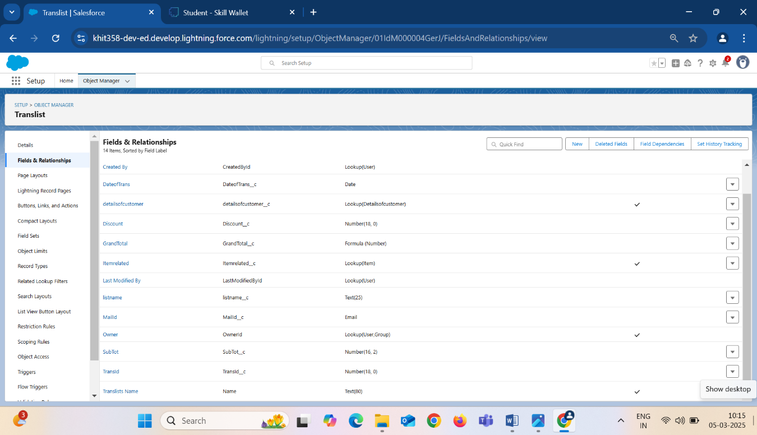

**Formula Field** **for Grand total field**:

Formula fields are custom fields that automatically provide results based on records and related records. In this project, GrandTotalfield uses formula field as a return type, where GrandTotal field is the total amount, after deduction of discount from total expense.

Create a formula field for Grand total field:

1. Click on insert field and add Subtot__c field.
2. Click on insert operator and insert the operator (-).
3. In the insert operator, insert “(” and “(”.
4. Add the field subtot__c and add operator “*”.
5. Add other field discount__c and “)”, “)”.
6. Add operator “/” and value 100.
7. Click on check syntax and make sure no errors are found.
8. Then, click on save.

In this, we used the formula:

**GrandTotal (Number) == Subtot__c -( (Subtot__c *  Discount__c)/100**

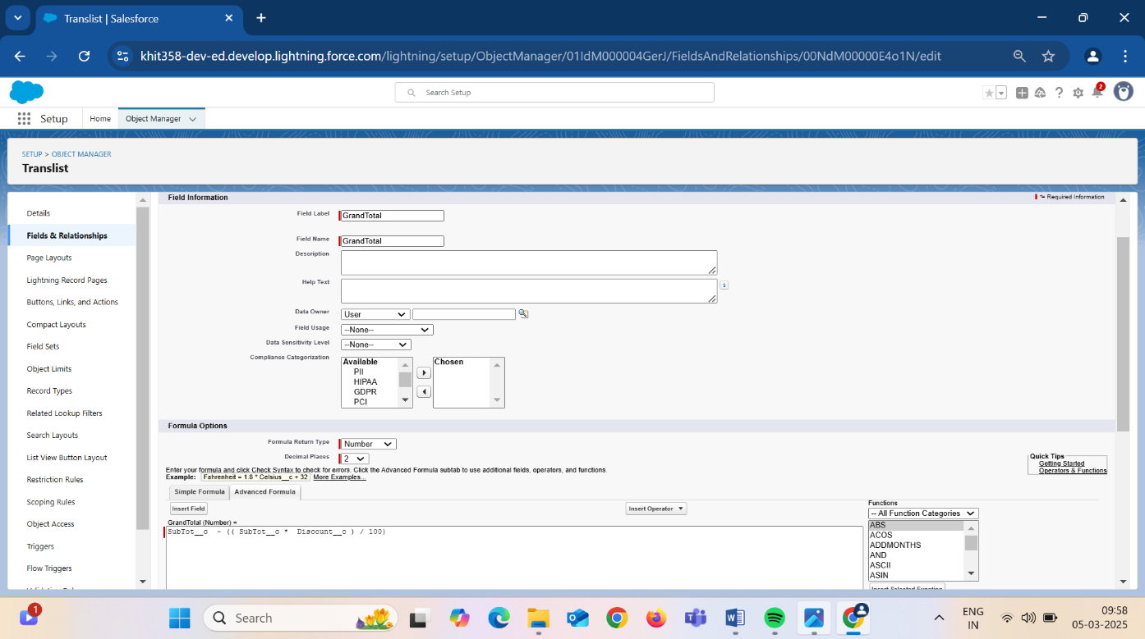

### **3.4.2 Create Fields for Detailsofcustomers:**

1. Click on object manager and search for object “Detailsofcustomer”.
2. Click on “Fields & Relationships” in the left panel.
3. Click on New and choose the data type that is required.
4. Click next and fill the following details in the mentioned.
5. Click Next, Next and click on “Save and New”.

|  |  |  |
| --- | --- | --- |
| S No | Field Label | Data Type |
| 1 | Details of customer name | Text (80) |
| 2 | mailid | Email |
| 3 | Contno | Phone |

6) Similarly create the fields contno, detailsofcustomer name, mailid.

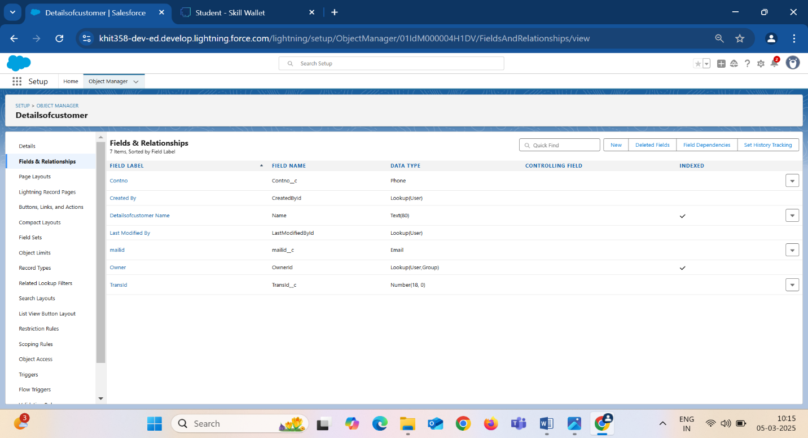

* + 1. **Create Fields for Items Object:**

1. Click on object manager and search for object “Items”.
2. Click on “Fields & Relationships” in the left panel.
3. Click on New and choose the data type that is required by the field you need.
4. Click next and fill the following details in the mentioned.
5. Click Next, Next and click on “Save and New”.
6. Similarly, Create the fields prodname, prodid, price, manfdate.

|  |  |  |
| --- | --- | --- |
| S No | Field Label | Data Type |
| 1 | Price | Number |
| 2 | manfdate | Date |
| 3 | prodname | Text |

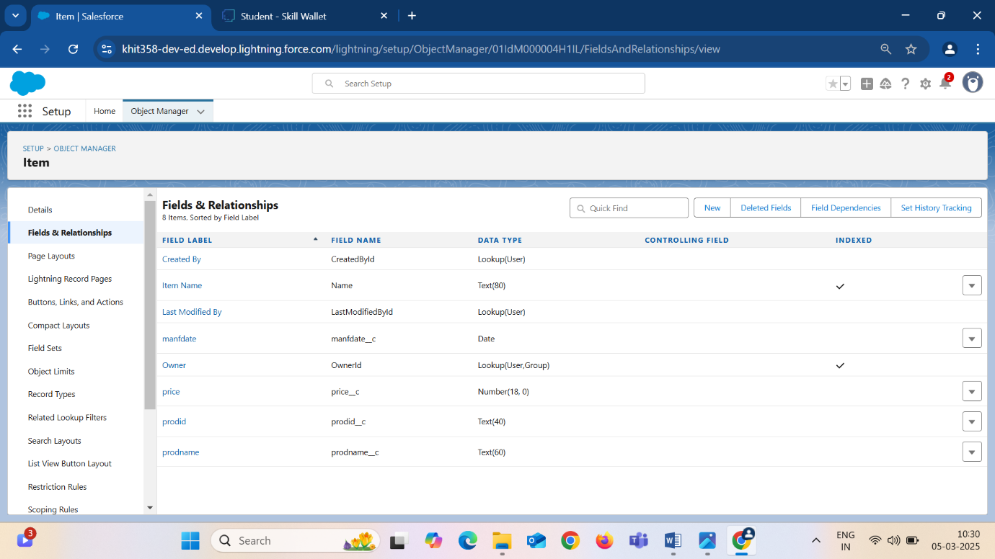

**3.5 The Lightning App**

An app is a collection of items that work together to serve a particular function. In Lightning Experience, Lightning apps gives users access to sets of objects, tabs, and other items all in one convenient bundle in the navigation bar.

Lightning apps let you brand your apps with a custom color and logo. You can even include a utility bar and Lightning page tabs in your Lightning app. Members of your org can work more efficiently by easily switching between apps.

**Custom Apps:**

Custom apps are created according to the needs of a company. They can be made by putting custom and standard tabs together. Logos for custom apps can be changed.

### **3.5.1 Creating an App** – **E-COMMERCE**

1. Go to setup, by clicking the gear icon present in the top right corner.
2. Navigate to Home bar and in the quick find box, search for App.
3. Click on APP MANAGER.
4. You can notice the screen like this. Now click on New Lightning App. You will find like this below.
5. Enter the App name **“E-commerce”**, the developer’s name gets automatically populated. If an image is required, you can browse the image and upload it.

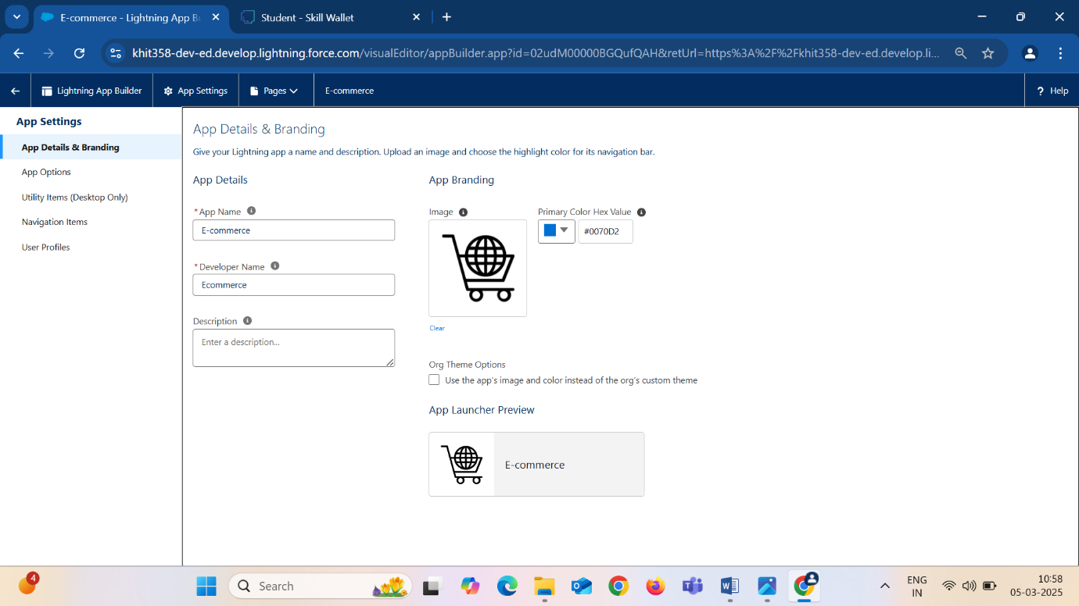

1. Click Next, Next and you can see a Navigation Items window.
2. In the filter list, enter translists, transorders, reports and Dashbords, detailsofcustomer, Items. Then navigate them to selected items.
3. Click on Next , and you can see User Profiles. This option is used when we want only certain profiles to access them.
4. Enter System Administrator in the filter box and add the system Administrator to the selected profile list.
5. Click on Save and Finish.
6. Now navigate to the App launcher and search for **E-commerce** and you can find the **E-commerce** app.

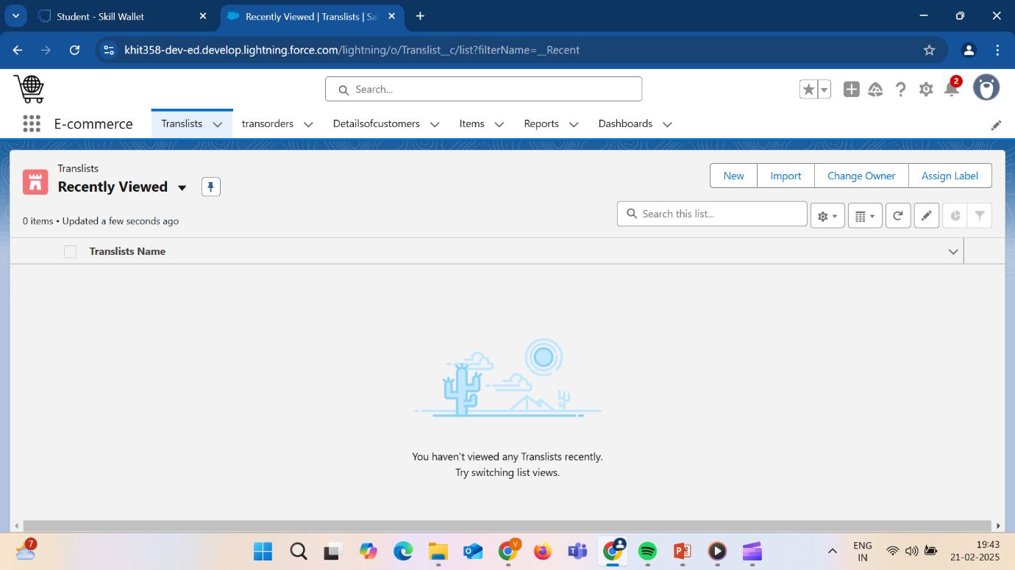

**3.6 User Adoption:**

User adoption in Salesforce refers to the process of ensuring that users whether they are sales representatives, managers, or administrators effectively integrate Salesforce into their daily workflows. It focuses on helping users understand the system's capabilities and navigate its various features with ease, enabling them to maximize its value.

### **3.6.1 Create a record for Items object :**

1. In the App launcher, visit **E-commerce** present in the app launcher.
2. You will find the products tab present in the app page, click on the tab.
3. Then click on NEW to insert a new record into the products object.
4. Create a Item Record -  **Prodname: Oreo, Price: 100**
5. Create a Item Record - **prodname: raspberry, Price : 200**
6. Create a Item Record - **prodname: cranberry, Price : 300**
7. Create a Item Record - **prodname: shakes, Price : 400**

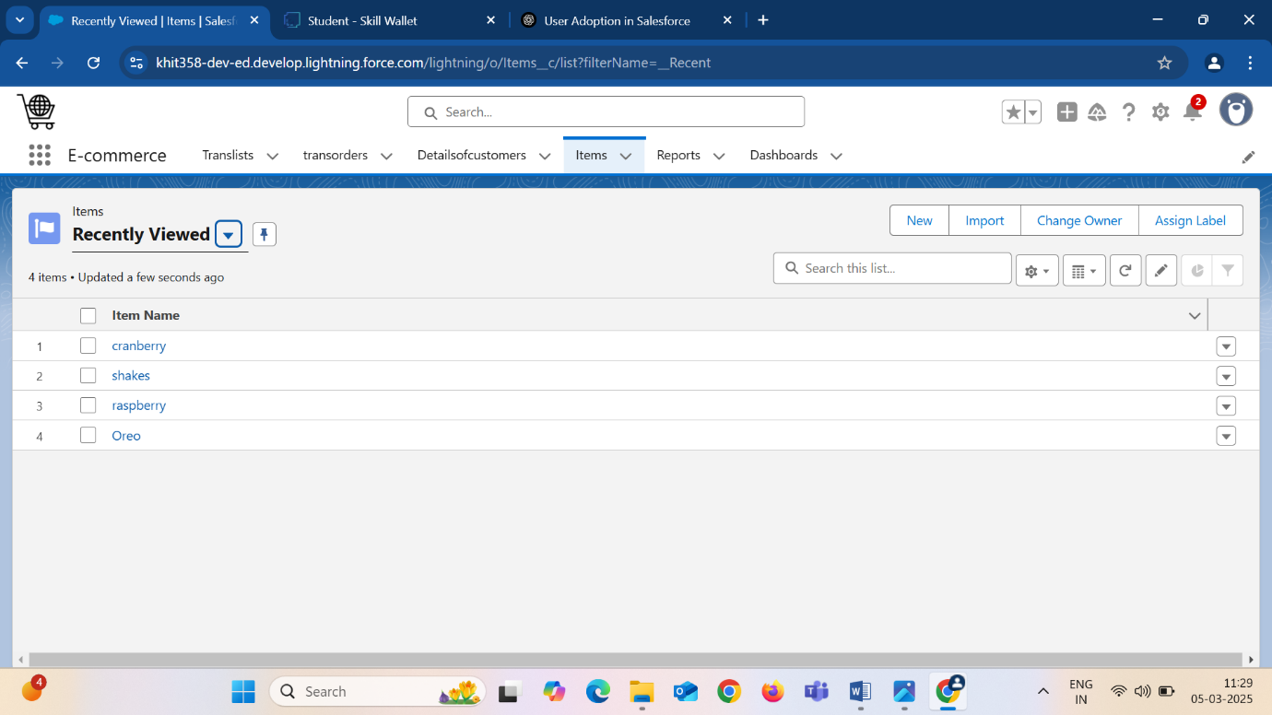

### **3.6.2 Create a record for translists object**

1. In the App launcher, visit **E-commerce** present in the app launcher.
2. You will find the Translists tab present in the app page, click on the tab.
3. Then click on NEW to insert a new record into the translists object.
4. After inserting a record in the tranlists object, click on the record created.
5. Similarly, you can click on the Item record and go to related, we can find the related  translists records to that Item.
6. While Creating the translists record, please insert Item also.

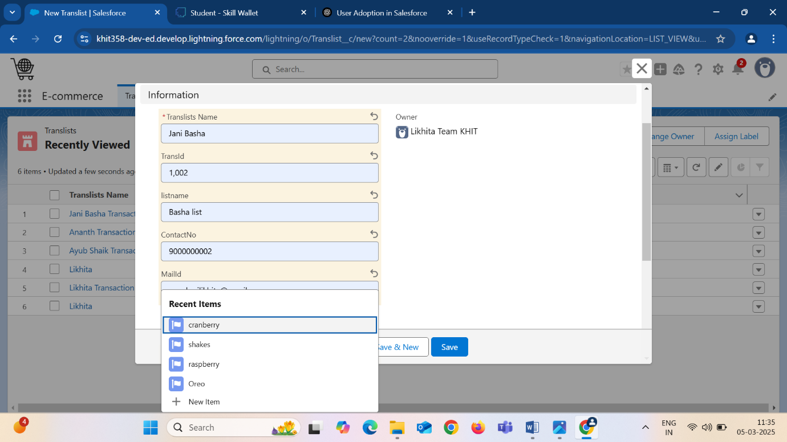

### These are the Translists Records created by including items

### 

### **3.7 APEX**

**Apex In-detail:**

Apex is a strongly typed, object-oriented programming language that allows developers to execute flow and transaction control statements on the Lightning platform server in conjunction with calls to the Lightning Platform API. Using syntax that looks like Java and acts like database stored procedures, Apex enables developers to add business logic to most system events, including button clicks, related record updates, and Visualforce pages.

**3.7.1 Identifying Potential Customers**

Now that we have the transaction data and performed related operations on the data acquired, it’s time we identify those who are interested i.e, potential or valuable customers for us. So, we need to run a program, to identify the potentialcustomers in a company, by finding the grand total expenses of an individual.

**Steps involved in writing the program:**

1. Navigate to gear icon, Click on Developer console. Now you will see a new console window.
2. In the tool bar, you can see FILE. Click on it and navigate to new and create New apex class.
3. Enter a class name **Grandsum** and click enter. You will find that a new class “Grandsum” is creates with public access specifier.

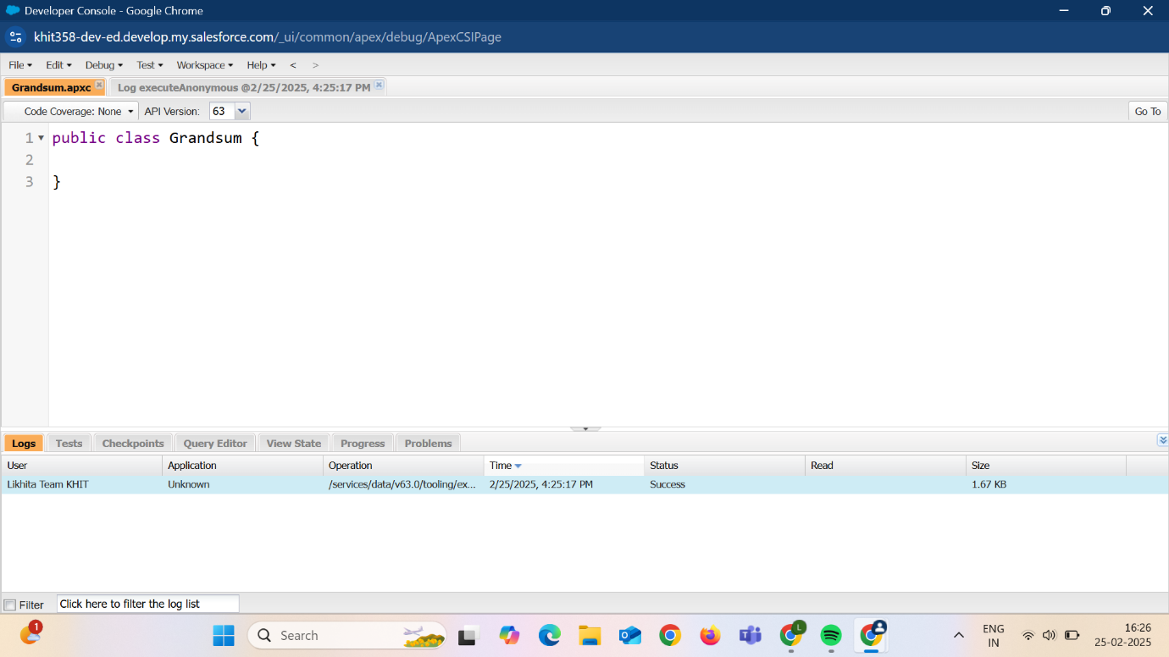

Method to find the Grandsum of Accounts :

* After creating the class, now create a new method called “SumofGrand”, with

public access specifier and a static notation.

* Now, in this method we need to perform the operation of finding the total grandsum of all the accounts.

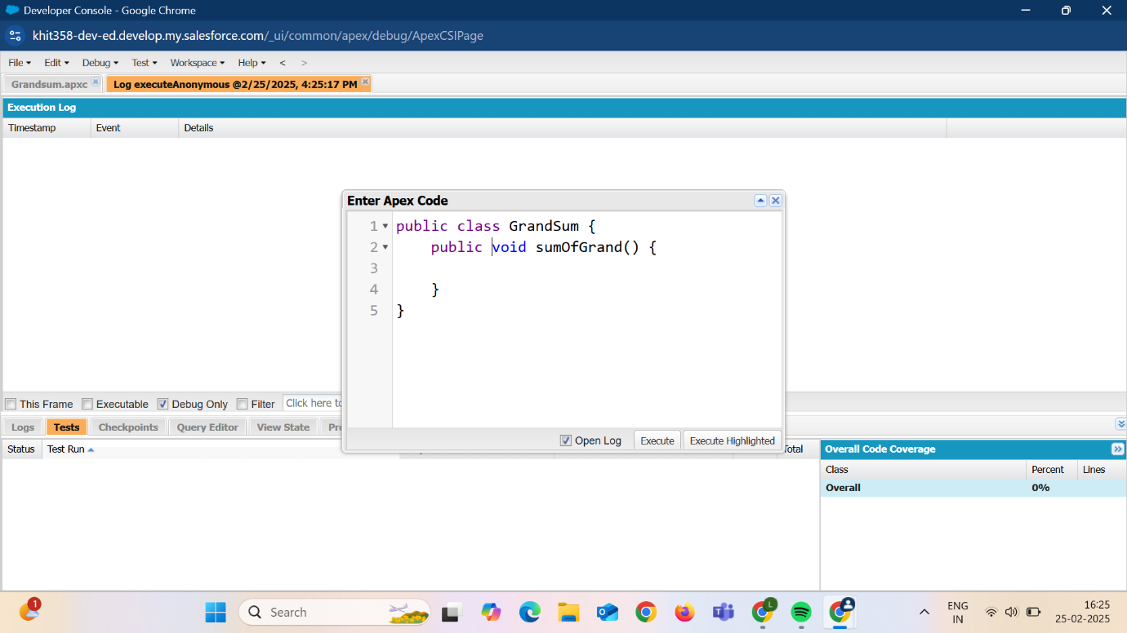

**Triggers:**

A trigger is a set of Apex code that runs before or after Data Manipulation Language events.

A DML event could be a variety of data processing tasks that include the standard insert, update, and delete commands.

**How to create a new trigger**:

1. In the trailhead account, navigate to the gear icon in the top right corner.
2. Click on developer console
3. Click on File menu in the tool bar, and click on newTrigger.
4. Enter the trigger name and the object to be triggered.

**Syntax For creating trigger:**

**The syntax for creating trigger is :**

**Trigger [trigger name] on [object name]( Before/After event)**

**{**

**}**

In this project, trigger is called whenever the particular records sum excede the threshold i.e. minimum business requirement value. Then the code in the trigger will get executed.

Trigger code:

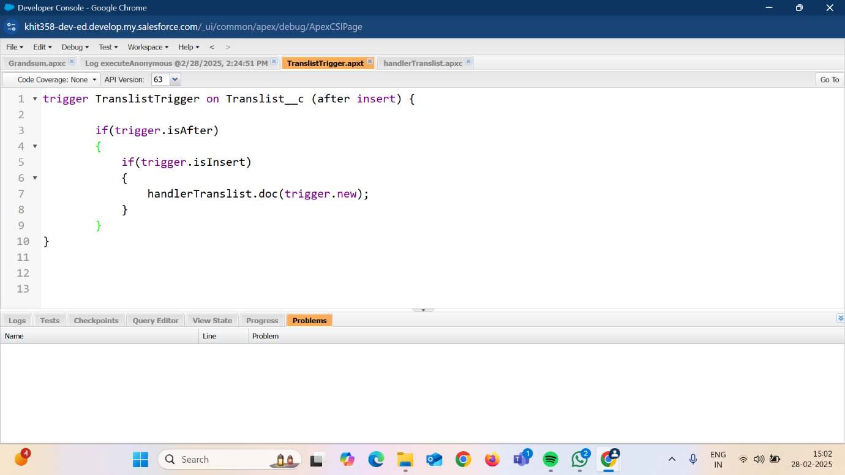

**Handler Class:**

The Handler Class would be designed to handle processes like order management, customer relationship tracking, and inventory updates. For example, when a customer places an order, the Handler Class might be responsible for ensuring that order records are correctly created, the stock levels are updated, customer details are captured, and communication is sent to the customer about their order status.

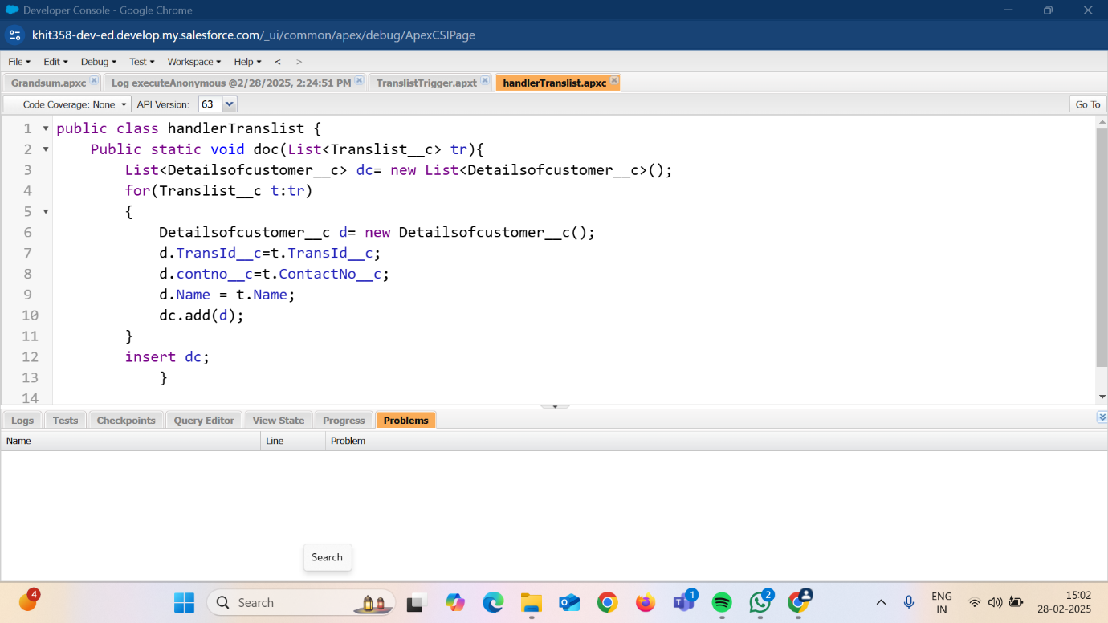

* Here in the trigger, whenever a record is inserted then automatically record is created in “Detailsofcustomer” object (Since they have lookup relationship).
* The Detailsofcustomer object fetches only the customer details like contactno, name and transactionid.

### **3.8 Apex Schedulers**

The Apex Scheduler lets you delay execution so that you can run Apex classes at a specified time. This is ideal for daily or weekly maintenance tasks using Batch Apex. To take advantage of the scheduler, write an Apex class that implements the Schedulable interface, and then schedule it for execution on a specific schedule.

**SYNTAX :**

**public class SomeClass implements Schedulable {**

**public void execute(SchedulableContext ctx) {**

**// add your code here**

**}**

**}**

### **3.8.1 Schedule the class – Translist email scheduler**

For a **CRM application on e-commerce activities**, scheduling a class could be useful for automating background tasks like updating inventory levels, sending out daily or weekly order summaries, we can ensure that these tasks are executed at precise times without manual intervention, ensuring smoother and more efficient operations.

* The body of the email and list of items need to displayed are in the below apex class **translistapexsender.apxt**

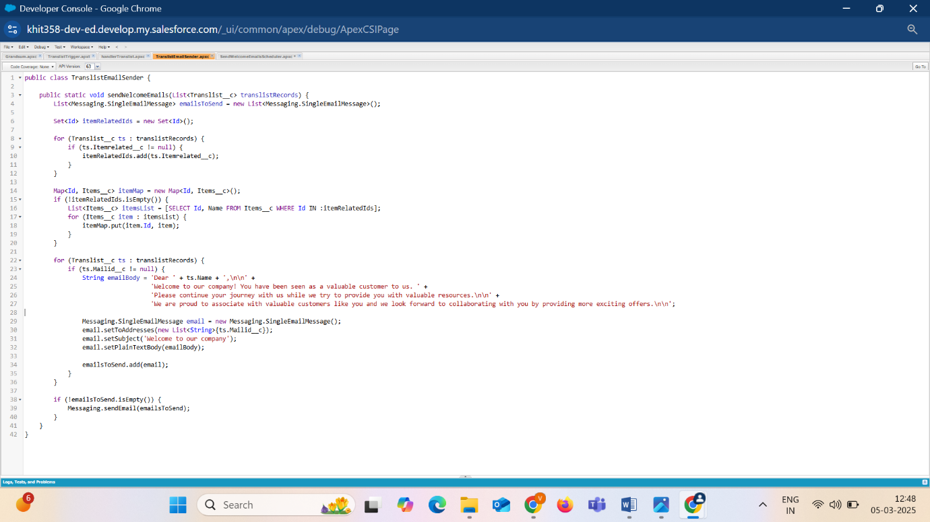

### **Schedule the Apex class:**

1. Go to Home page in your salesforce account.
2. In the search bar, enter Apex and click on Apex Classes.

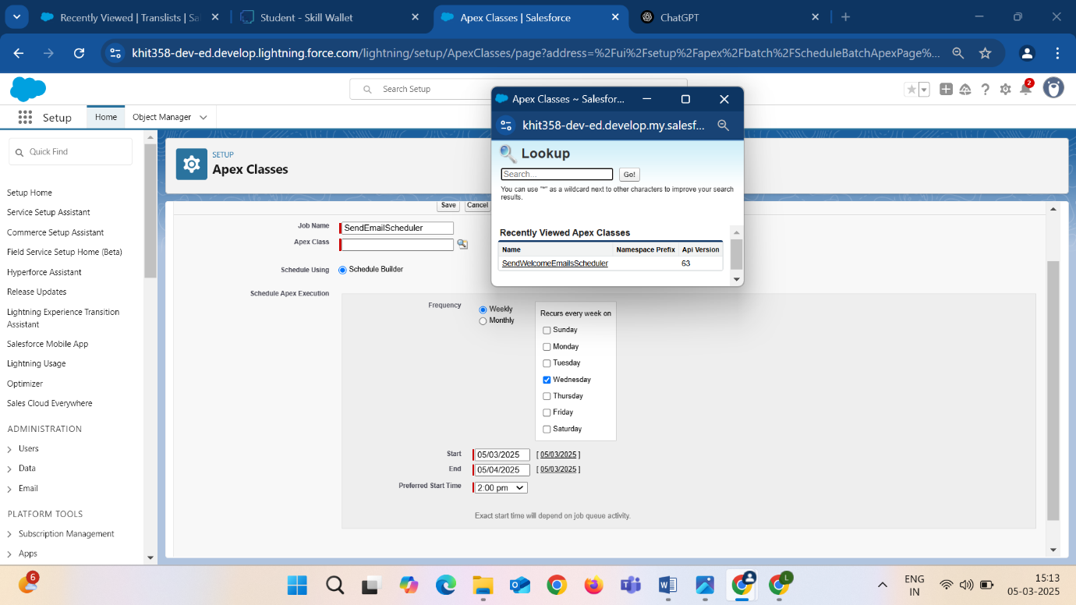

1. Click on Schedule Apex and enter the Job name.
2. Now click on the search icon present near the Apex class.
3. In the Schedule Apex section, select from the choice list and select a Start and End date.
4. Click on Save. Now enter Apex in the search box and select Apex jobs.

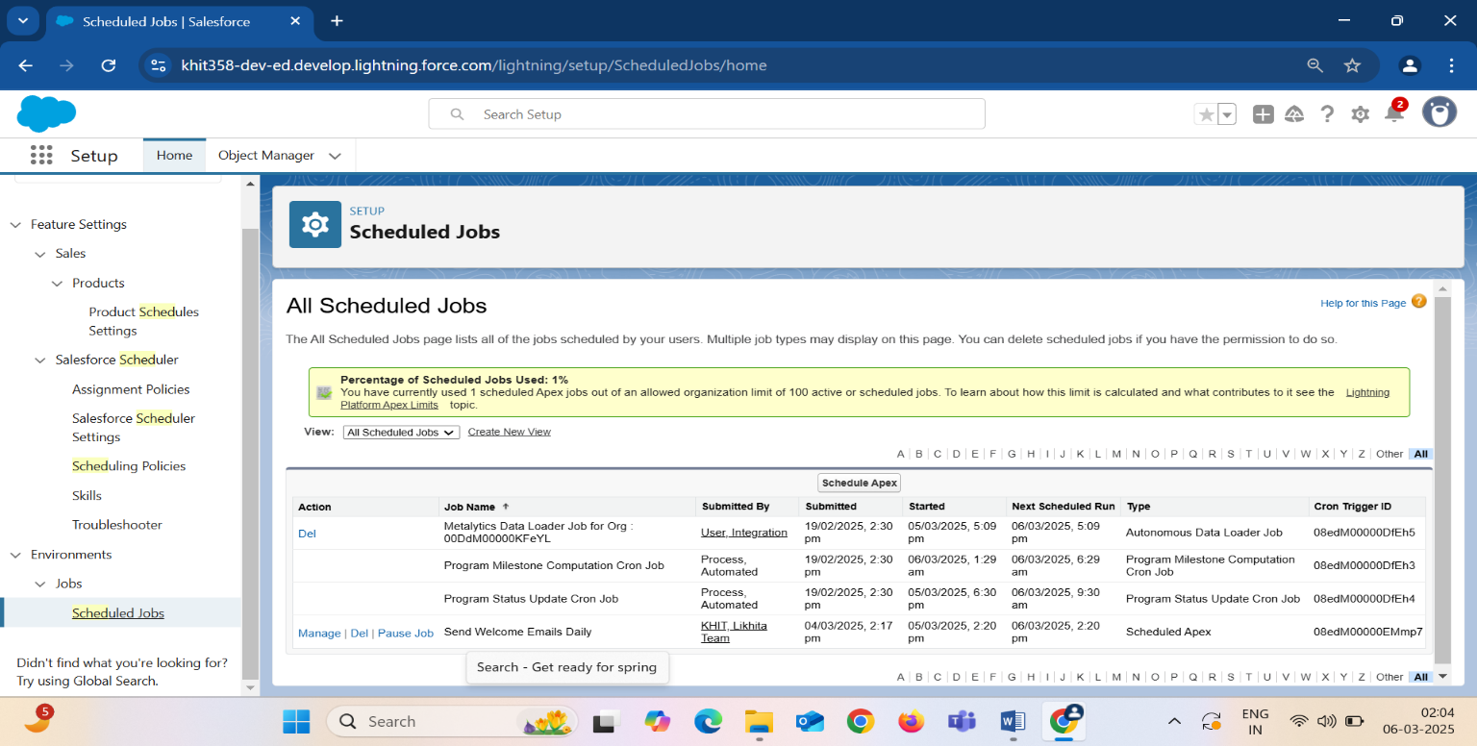

**Testing and Validation : Scheduled Mails to Customers**

1.Mail scheduled to customer: Ayub shaik

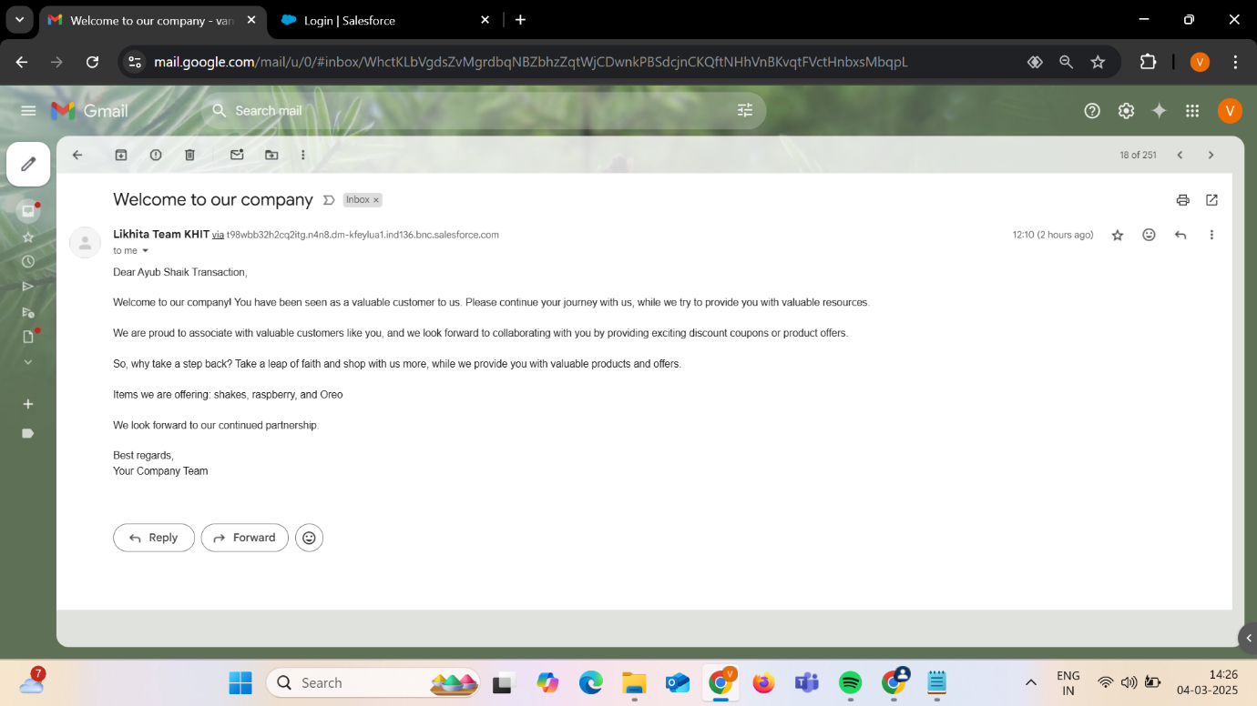

2.Mail scheduled to customer: Ananth

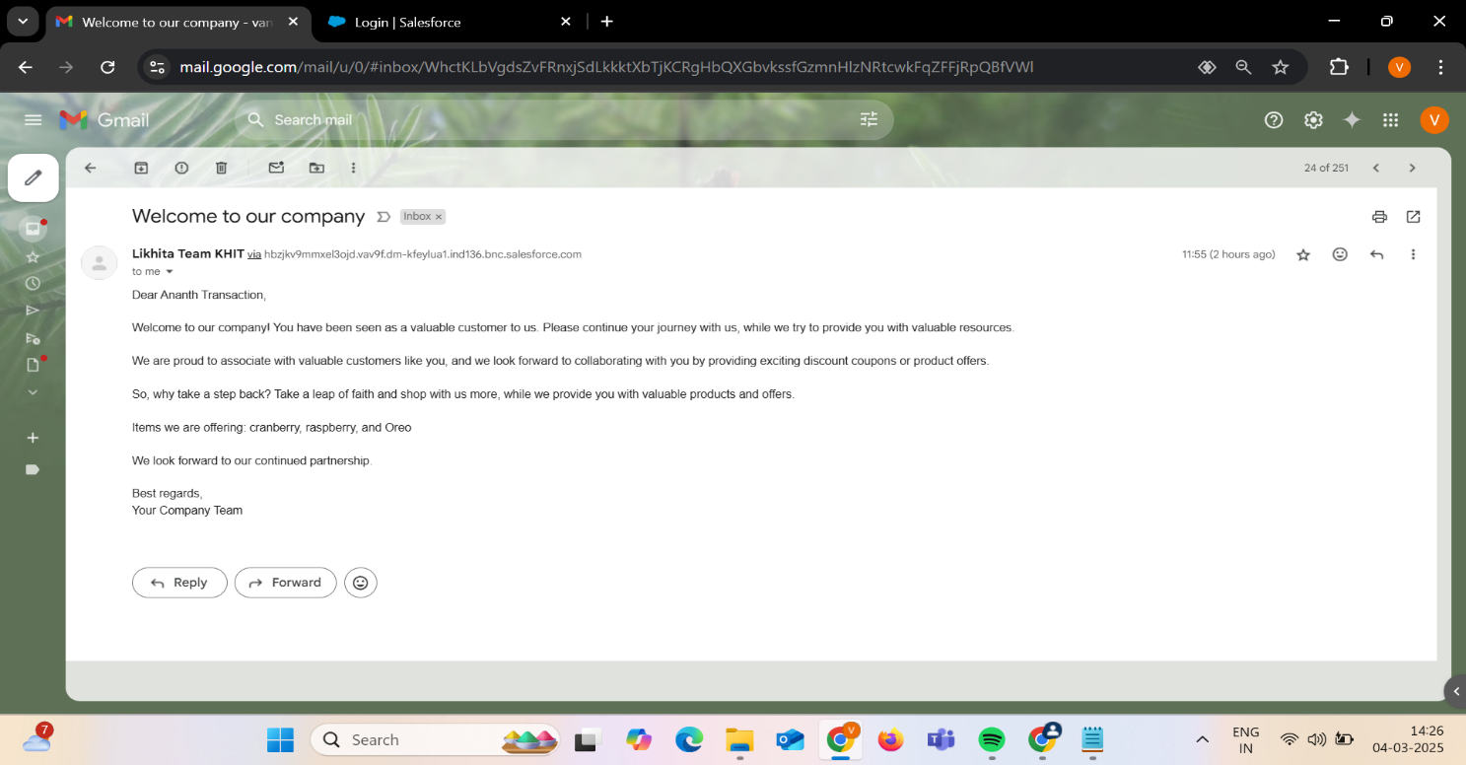

3.Mail scheduled to customer: Likhita

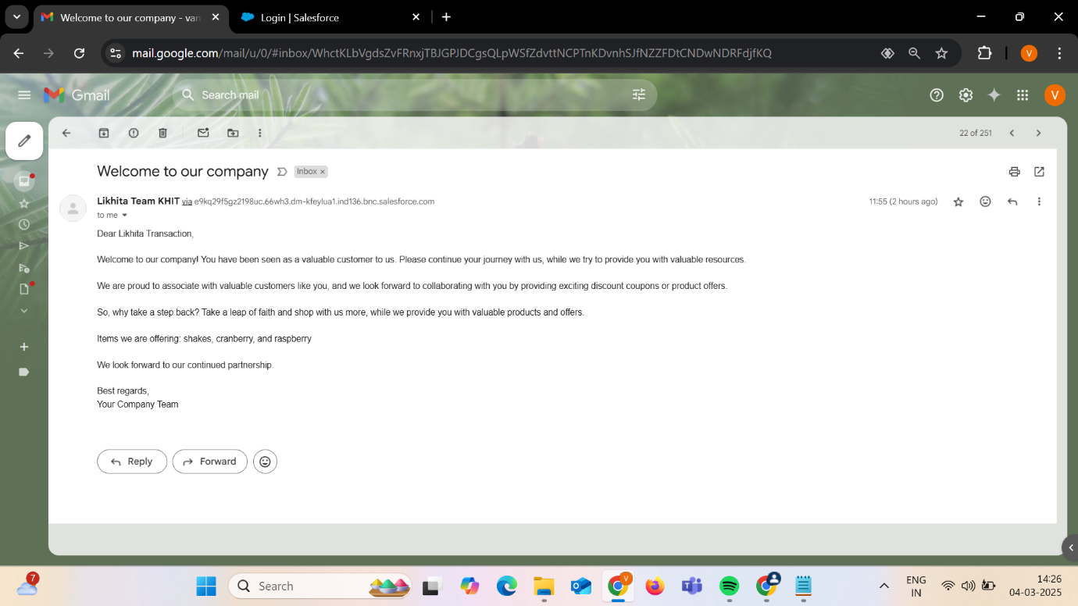

4.Mail scheduled to customer: Jani Basha

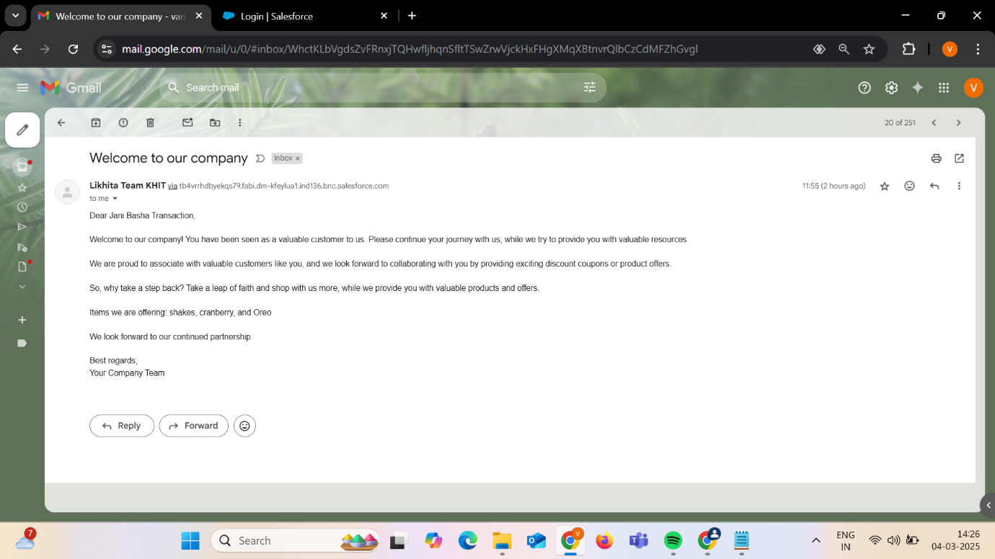

**3.9 Reports**

Reports give you access to your Salesforce data. You can examine your Salesforce data in almost infinite combinations, display it in easy-to-understand formats, and share the resulting insights with others. Before building, reading, and sharing reports, review these reporting basics.

### **3.9.1 Create Report for translists**

Go to the app now click on the reports tab

1. Click New Report.
2. Click on All category and find “translists” object.
3. Click on start Report.
4. In the columns list, add the fields transid, contact no, subtot, discount and grandtot. And in the Groups Column, add transid field to filter the records based on number of transactions.
5. After adding the columns, click on the Toggle icon highlighted. You can see only the fields selected and all the records.
6. Upon adding the columns, now click Save and enter the name of the report.
7. Click on Save and Run.

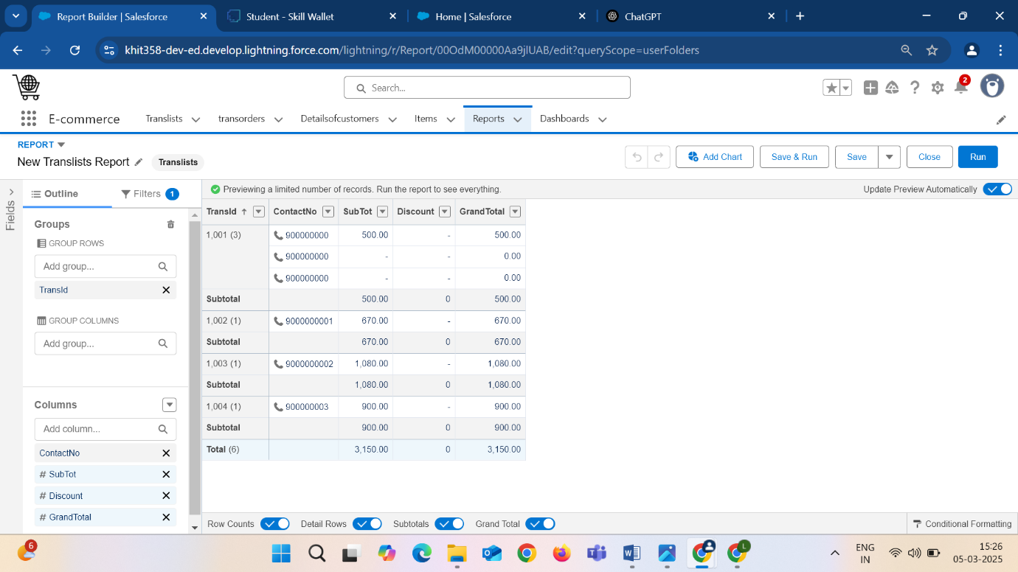

**3.9.2 Create Report for Items**

Go to the app now click on the reports tab

1. Click New Report.
2. Click on All category and find “Items” object.
3. Click on start Report.
4. On the left panel, you can see Group Rows and Columns. Add the following items shown in the image below.
5. Click on save. Save the report with a name. Click Run.

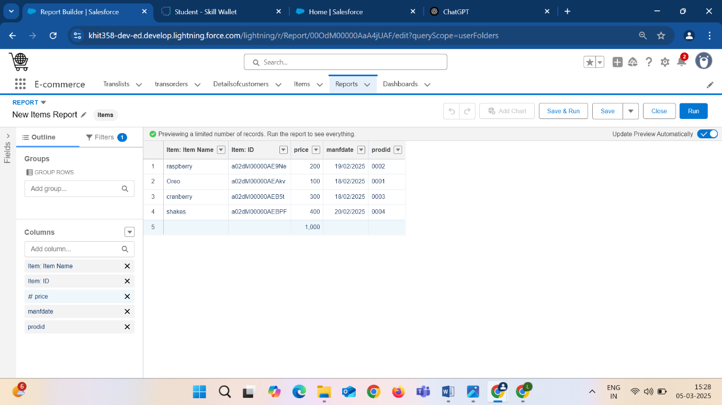

**3.10 DASHBOARDS**

Dashboards help you visually understand changing business conditions so you can make decisions based on the real-time data you’ve gathered with reports. Use dashboards to help users identify trends, sort out quantities, and measure the impact of their activities. Before building, reading, and sharing dashboards, review these dashboard basics.

**3.10.1 Create a dashboard on Translists report**

Go to the app now click on the Dashboards tabs.

1. Click on **New Dashboard.**
2. Enter the Name of the dashboard and description(optional).
3. Upon clicking create, you will notice an empty dashboard. Click on New component.
4. Click on **“+ Widget”,** and click on **translists report.**
5. Click on select and in the add component section, select all the fields required for the dashboard. Click on add component and add display as pie chart view.

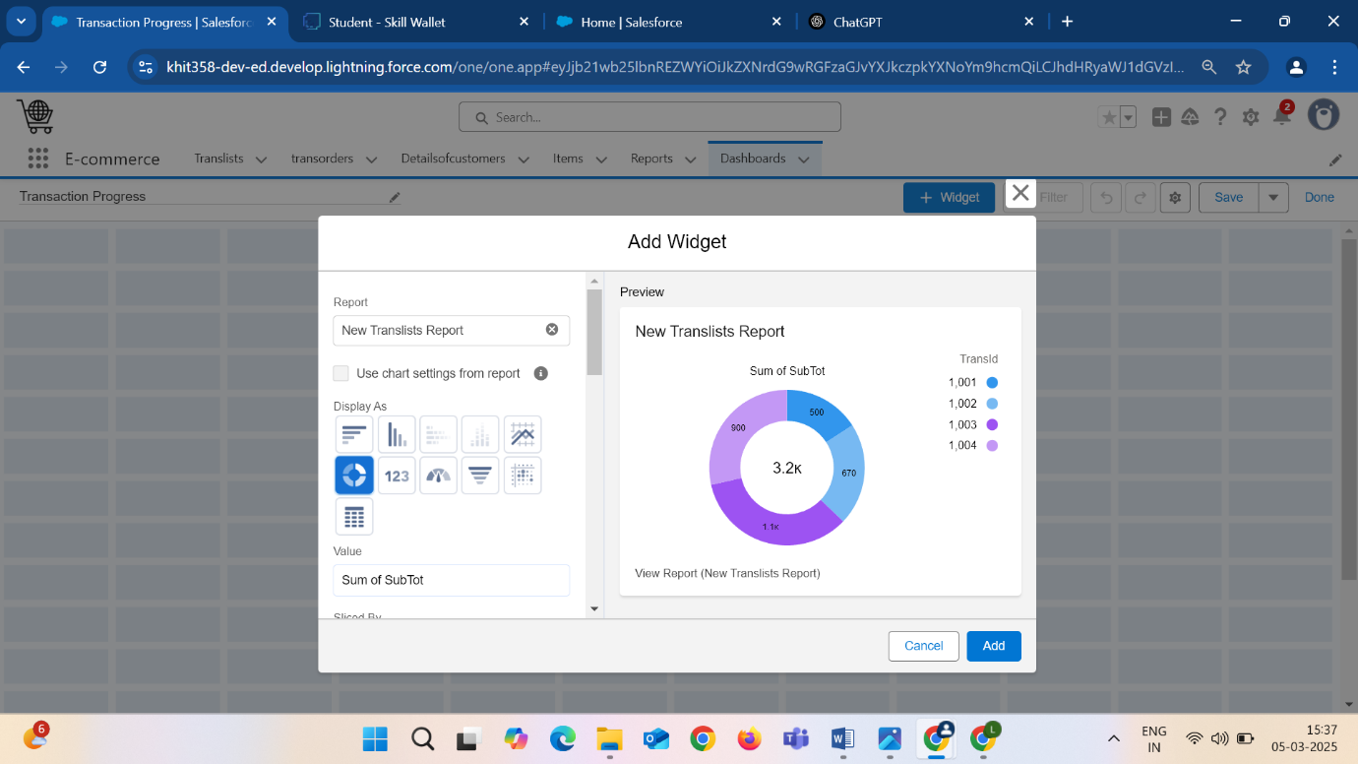

1. Add **another component** on **translists reports**, select Gauge representation and add the component.
2. Select the Measure as Record count to maintain the number of transaction count and select the checkboxes Show Percentages, Show Values and Show Ranges.
3. Add **segment ranges as 0,10,30,50** and add the component.

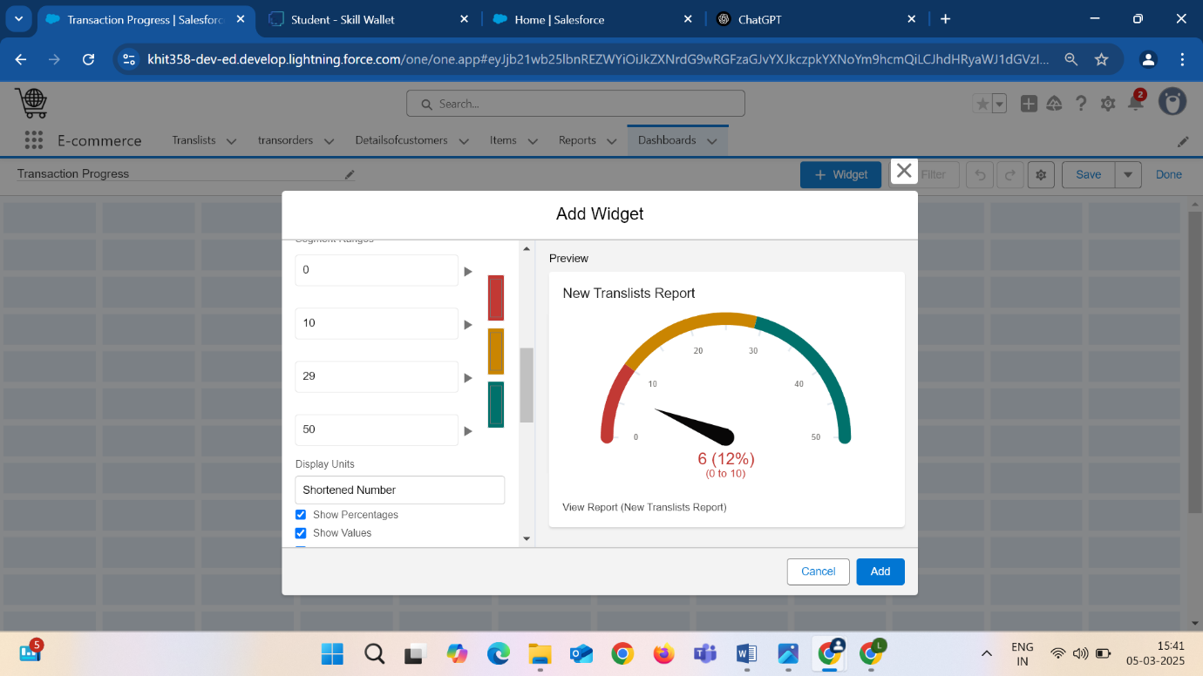

1. You will view the translists report on the dashboard page. Click on done and Save.

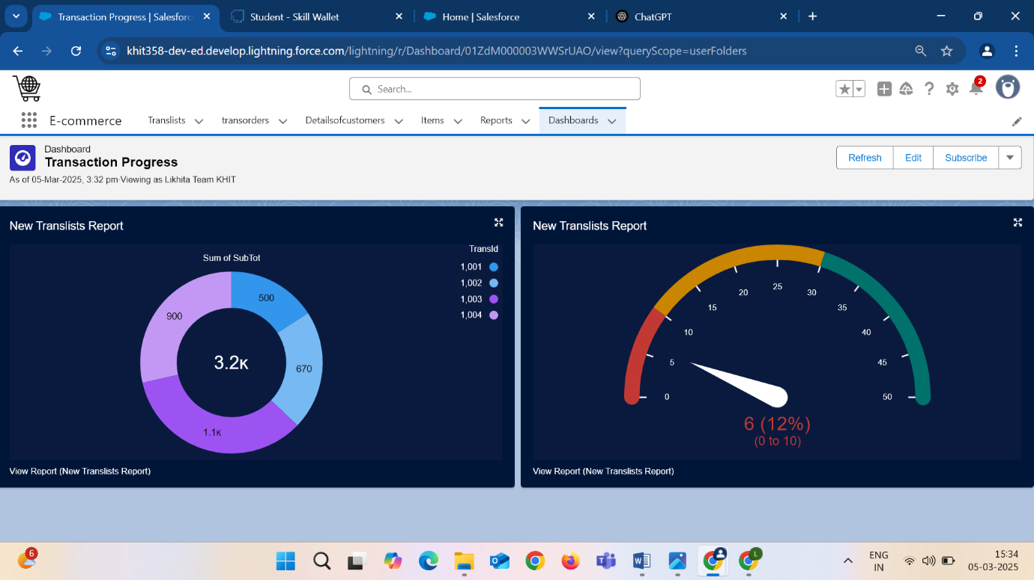

**3.10.2 Create a Dashboard on Items report**

1. Click on **new Dashboard.**
2. Enter the name of the dashboard.
3. Upon clicking create, you will notice an empty dashboard. Click on New component.
4. Click on **“+ Widget”,** and click on **items report**.
5. Click on select and in the add component section, select all the fields required for the dashboard. Click on add component and add display as pie chart view.
6. Click on add. You can now see the pie chart dashboard of how many of those items are most sold and count of the items.

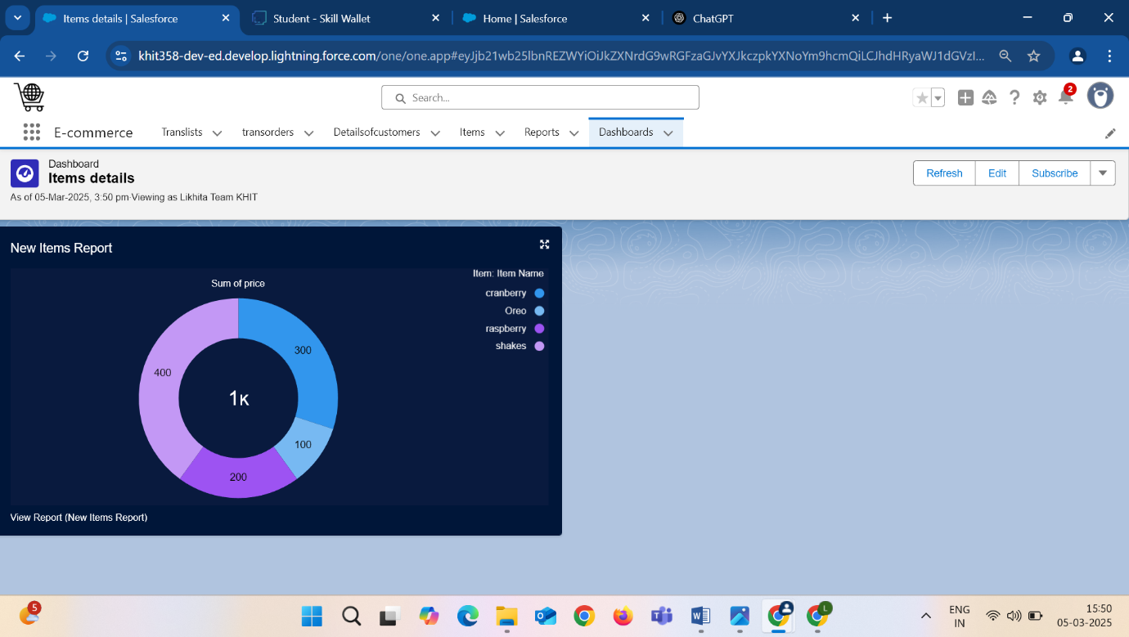

**OUTCOMES**

The implementation of the **“CRM Application on E-Commerce Activities”** has yielded several positive outcomes for the business, both in terms of operational efficiency and customer satisfaction. One of the most significant outcomes has been the streamlined management of customer data, which has become more organized and easily accessible. By leveraging Salesforce CRM capabilities, the application enables a 360-degree view of each customer, tracking interactions, purchases, preferences, and feedback. This has led to better-targeted marketing campaigns, personalized recommendations, and improved customer loyalty.

Another key outcome is the automation of routine tasks such as order processing, inventory updates, and customer engagement like following -up emails, promotional offers and discounts. This has drastically reduced the manual effort required from staff, allowing them to focus on more strategic initiatives.

The automation of these processes has also improved order accuracy and timeliness, leading to higher customer satisfaction and fewer complaints. Additionally, real-time analytics and reports on sales, stock levels.

Customer behaviour have empowered the business to make data-driven decisions, optimize inventory, and adapt marketing strategies to meet changing customer needs.

Finally, the application’s seamless integration with other e-commerce tools and platforms has allowed for a unified view of the business's online activities. This ensures that all departments, from marketing to sales to customer service, work from the same up-to-date information, improving collaboration and decision-making.

**CHALLENGES & SOLUTIONS**

While the implementation of the CRM application for e-commerce activities has brought numerous benefits, there have also been several challenges that needed to be addressed to ensure the project’s success.

**Challenge 1: Data Integration**

One of the initial challenges was integrating the CRM application with various e-commerce platforms, other third-party systems. Data from different sources was often inconsistent or manual updates, which could result in delays or errors.

**Solution:**  
To address this, our project team used Salesforce's **API capabilities** and **middleware tools** to create seamless integrations between the CRM and other systems. They also implemented **data validation rules** and **deduplication processes** to ensure that all data was clean and standardized.

**Challenge 2: User Adoption**

Another challenge was ensuring that employees particularly those without a technical background could quickly adapt to the CRM system. Some team members were hesitant to switch from traditional methods to a new software solution.

**Solution:**  
To overcome this challenge, the team invested in **user training** and used **Salesforce Trailhead** to provide role-specific learning paths. Additionally, **in-app guidance** and **helpful resources** were provided to assist users as they navigated through the system.

**Challenge 3: Data Security and Privacy**

E-commerce businesses handle a large amount of sensitive customer data, including payment information and personal details. Ensuring that the CRM application adhered to data protection regulations (such as GDPR) was a major concern.

**Solution:**  
The team implemented Salesforce’s **advanced security features**, including **field-level encryption**, **multi-factor authentication**, and regular **security audits** to ensure the system complied with data protection standards.

**Key Scenarios Addressed for Salesforce on Implementation of Project**

In the implementation of a CRM (Customer Relationship Management) application for eCommerce activities using **Salesforce**, several key scenarios are typically addressed. These scenarios focus on improving the customer experience, streamlining operations, and increasing sales and marketing effectiveness. Below are the main scenarios that Salesforce would address in such a project:

**1**. **Customer Data Management**

**Scenario**: A comprehensive view of the customer journey is required, including tracking interactions, purchases, and preferences.

**Salesforce Solution**: Salesforce provides a **360-degree customer view** by consolidating customer data from various touchpoints such as website visits, purchase history, and support interactions into a single platform (Salesforce Customer 360). This data helps eCommerce businesses understand customer behavior, personalize offers, and improve service quality.

### **2**. **Lead and Opportunity Management**

**Scenario**: Managing and tracking leads from different sources, and converting them into paying customers, is a critical part of eCommerce business growth.

**Salesforce Solution**: Using **Salesforce Sales Cloud**, leads generated from website interactions, marketing campaigns, or customer inquiries can be automatically captured, assigned to sales reps, and tracked through customizable stages of the sales pipeline. This helps in improving the lead conversion rate.

### **3. Order Management**

**Scenario**: eCommerce businesses need to manage customer orders from initial purchase to delivery while ensuring a seamless experience across various channels.

**Salesforce Solution**: Salesforce can integrate with **Salesforce Commerce Cloud** or third-party tools to track orders and inventory in real-time, streamline fulfillment processes, and enable efficient communication with customers about order status, shipping, and returns.

### **4. Customer Support and Service**

**Scenario**: eCommerce businesses must provide excellent post-purchase support, including handling inquiries, returns, refunds, and technical support.

**Salesforce Solution**: Salesforce’s **Service Cloud** can be utilized to create a seamless support system. It provides case management, automated workflows for issue resolution, live chat integration, and omnichannel support (email, phone, social media, etc.). Customer service reps can access detailed customer information to provide personalized support.

**5.** **Marketing Automation**

**Scenario**: eCommerce businesses need to run targeted marketing campaigns based on customer behavior to drive sales and repeat purchases.

**Salesforce Solution**: With **Salesforce Marketing Cloud**, businesses can design automated email campaigns, personalized promotions, and customer loyalty programs. Data-driven insights help marketers segment customers and send relevant offers, increasing the chances of conversion.

6. **Customer Segmentation and Personalization**

**Scenario**: Customers have different preferences and buying behaviors, so personalized marketing and sales efforts are crucial for driving engagement.

**Salesforce Solution**: **Salesforce Einstein AI** can analyze customer data to segment them based on preferences, buying patterns, and demographics. The CRM can then automate personalized recommendations for products, discounts, and promotions based on this segmentation.

**CONCLUSION**

The **CRM Application on E-Commerce Activities** has proven to be a transformative tool for managing customer relationships and driving sales growth in the e-commerce domain. Through automation, data integration, and personalized customer engagement, the system has significantly enhanced operational efficiency and customer satisfaction. Expanding automation capabilities will allow the CRM application to remain at the forefront of e-commerce innovation. Ultimately, this CRM application has not only improved business processes but has also contributed to building stronger customer relationships, driving loyalty, and increasing profitability in the highly competitive e-commerce landscape.

In conclusion, the **“CRM Application on E-Commerce Activities”** has demonstrated its value as a key enabler of business growth and customer satisfaction in the e-commerce sector. By automating critical processes, centralizing customer data, and offering actionable insights, the application has optimized internal operations and enhanced the overall customer experience.